**A Member asks ….**

**Tortoiseshell – Real and Faux for Knitting Needles**

This month’s exploration is not about a tool, but about a substance. The *Sand and Shell* presentation at Melbourne’s May meeting prompted a discussion about tortoiseshell and faux tortoiseshell.

Presenter Judy Hopkins noted that tortoiseshell has been used since ancient times in Asia and the West. Wikipedia says, “It was used, normally in thin slices or pieces, in the manufacture of a wide variety of items such as [combs](http://en.wikipedia.org/wiki/Comb), small boxes and frames and inlays in furniture and other items, frames for spectacles, [guitar picks](http://en.wikipedia.org/wiki/Guitar_pick) and [knitting needles](http://en.wikipedia.org/wiki/Knitting_needle). Despite being expensive, tortoiseshell was attractive to manufacturers and consumers because of its beautiful mottled appearance, its durability, and its organic warmth against the skin.”

Tortoiseshell is a natural thermoplastic, and was treated with hot water and steam to separate the layers and to bend, fuse, and shape it. But the industrial revolution in the 18th and 19th centuries accelerated the ease of killing and replaced the work of craftsmen with mechanised processing. In 1973 harvesting and sale were banned, as the useable species had become endangered by over-killing. The slaughter didn’t stop, of course; and in 1996, the hawksbill turtle, the most important species used for tortoiseshell objects, was listed as “gravely endangered”.

Also in the 19th century, synthetics were developed in place of “torti”, the affectionate nickname for tortoiseshell. Cellulite compounds could be produced to look almost like the real thing, although the mottling appeared more on the surface rather than being three-dimensional. Many early 20th century needlework items were produced in faux torti, including needle cases, bodkins, thread winders, crochet hooks, and, of course, knitting needles.

The chief disadvantage of early cellulose nitrate products was their inflammability, especially in the days when candles or oil lamps were used to light the needlewoman’s work. Another drawback was the unstable nature of this early synthetic. Collectors are accustomed to watching favoured pieces disintegrate, first with crazing completely through the substance, and then sometimes, breaking into pieces.

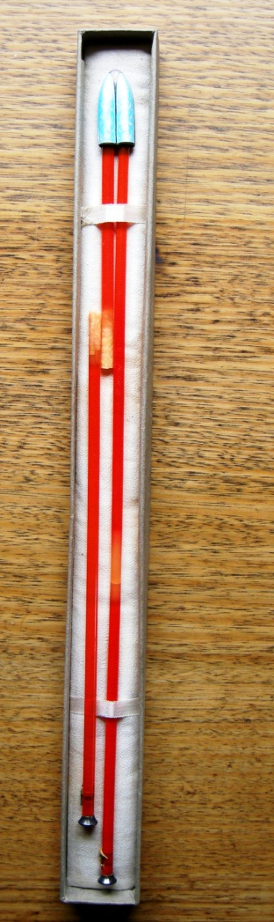

*A boxed set of cellulite knitting needles, including an enamelled point protector to hold stitches on the needle, sterling stoppers with enamelled posies on the other end, and a monogram pinned into the shaft near the stopper. These fancy sets – almost too good to use – were sold in department stores, jewellery shops, and, possibly, by mail order catalogue. Unfortunately, here the synthetic resin was unstable, as indicated by the lighter patches of crazing and the fact that one needle has broken in two.*

From the 1920s cellulose acetate began to replace cellulose nitrate. This newer plastic material was non inflammable and could be manufactured in sheets.

Faux torti knitting needles were prized by knitters from the 1920’s to about the 1980’s for their light weight and their flexibility; they were considered “kind” to arthritic hands and could be used for day-long knitting sessions, it was claimed, without causing the fingers to cramp or ache. About the time that “hatched” warning began to appear on every third surface, it was recognised that the chemical processes to make faux tortoiseshell were hazardous, and possibly carcinogenic; and manufacture of the faux torti needles ceased.

Before manufacture was halted, Patons was the biggest selling brand. These were made in Australia and batches of them are often on sale on line, with high praise written up by overseas sellers who manage to get their hands on them. But Patons were not the only brand name. Shellite and Quicknit were two other Australian brands. Quicknit also had a specialty called Torta Shell. British brands included Halex and Tabitha. Wimberdar also sold a tortoiseshell needle. All except the Patons are now quite rare, with Tabitha and Wimberdar most difficult to find.

In Australia, the Swallow Manufacturing Company of Melbourne now makes knitting needles from the milk-product casein, fixed with formaldehyde, under the brand name Timbergrain. Their website claims, “The tortoise shell knitting needle is sadly a thing of the past, but the latest casein plastic technology has allowed us to create its best features.... Swallow Timbergrain are the tortoise-shell knitting needles of the future.” But Timbergrain do not look or feel quite the same as the old cellulose acetate, so we will see.

But were any knitting needles made of *real* tortoise shell? Here the Melbourne meeting diverged, with some members asserting that they owned genuine tortoiseshell needles from the 19th century. Other members were confident it was not possible to make a stable pointed shaft because the layers of tortoiseshell would lift or flake off as the knitting needles were used, resulting in damage to yarn and very inefficient knitting before the whole shaft disintegrated.

Research after the meeting did not shed much light. Authorities like Richard Rutt (1989) and Sylvia Groves (1964) both noted that 19th century knitting needles had been made of tortoiseshell, but they did not refer to any evidence, nor show any examples. Articles on tortoiseshell said it was used to make knitting needles, but the articles also had no references, nor any examples. So, this seems like a circular argument – each side relies on the other.

Back home I dug out my own costly “genuine” tortoiseshell examples. Three pair have been acquired over the years. The most interesting thing when looking at all three pair together is that they were very, very dark with only faint mottling. According to authorities, some genuine tortoiseshell was very dark and “un-mottled”, , so perhaps certain kinds of turtle with less desirable markings were the species that could be used to make knitting needles.

But another possibility exists. Experts note that other, cheaper natural thermoplastics like cow horn were sometimes substitutes for tortoiseshell. This substance was much more common and was, apparently, easier to work and was used for some knitting needles. Perhaps time has clouded the distinctions between such natural substances, and, as usual, we apply the more prestigious designation.

**SW**